Grading Document - Lab 2

For your grading of lab 2.

## Pre Lab

Each pre lab question is worth 1 point (sub questions included).

1. MEMS Accelerometers:
   1. What does the MEMS Accelerometer actually measure?
      1. Answer: The sensor actually measures the capacitance between ‘combs’ (as shown below).
      2. Half Credit: Sensor measures voltage change.
   2. Visually describe how the sensor works in principle. How might it fail?
      1. Visual description: something like this:
         1. 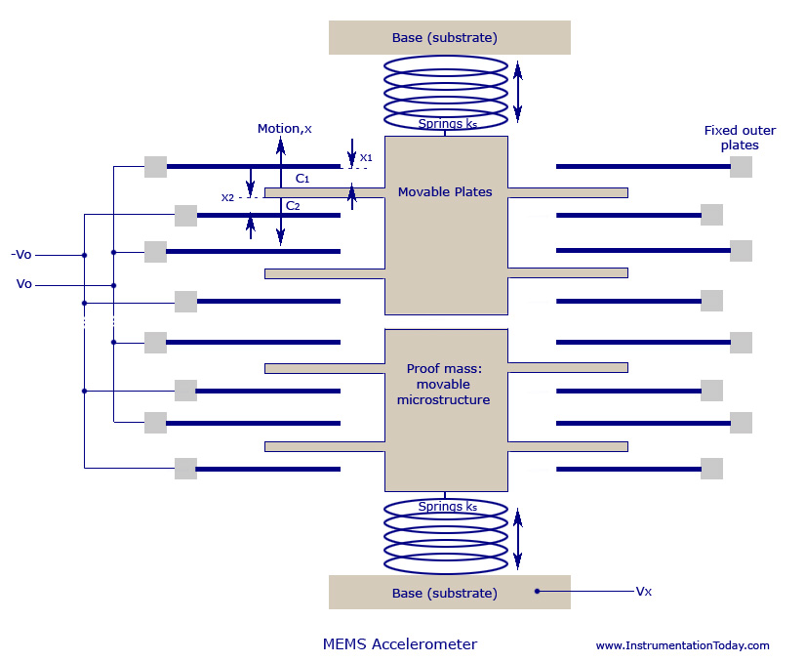
      2. How might it fail?
         1. Acceptable answers: pins break or bend from high force, dirt gets inside.
2. Why do we need to calibrate sensors?
   * 1. Answer: Sensors may respond differently than the ideal way outlined on the datasheet because of manufacturing issues. This will give us the best accuracy with the sensor.
        1. Reason 1 from website: “No sensor is perfect.”
        2. Reason 2 from website: “The Sensor is only one component in the measurement system.”
   1. What is one-point calibration? When do we need to use it?
      1. Answer:
         1. Shifting the response curve by a known value. Its just using an offset.
         2. Used when sensor is linear and the response slope is correct.
   2. What is two-point calibration? When do we need to use it?
      1. Answer:
         1. Part 1, from website: “A Two Point calibration essentially re-scales the output and is capable of correcting both slope and offset errors.”
         2. Part 2, from website: “Two point calibration can be used in cases where the sensor output is known to be reasonably linear over the measurement range.”
   3. What is multi-point curve fitting? When do we need to use it?
      1. Answer:
         1. From website: “Sensors that are not linear over the measurement range require some curve-fitting to achieve accurate measurements over the measurement range.”
3. What exactly is a breakout board? What are the advantages of using them?
   1. Answer:
      1. Part 1, from website: “The basic concept of a breakout board is that is takes a single electrical component and makes it easy to use… A breakout board “breaks out” these pins onto a printed circuit board that has its own pins that are spaced perfectly for a solderless breadboard, giving you easy access to use the integrated circuit.”
      2. Part 2. They save space, are reusable between projects, pins are labelled nicely, pins can be accessed easily, good documentation.

### Lab Discussion Questions

Two points per question.

1. **Discussion Question 1:** What is the range of voltage that can sufficiently power the accelerometer chip?
   1. Answer: 1.8 to 3.6 V (from page 1)
2. **Discussion Question 2:** How many axes can this accelerometer sense? Which ones? What names does the datasheet give to the pins that push out voltage for each axis?
   1. Answers: There are three axes on this accelerometer, for X, Y, Z axes. Each is called Xout, Yout, and Zout, respectively.
3. **Discussion Question 3:** What is a g? (this one is not on the datasheet and you will need to look it up)
   1. Answer: A g is one acceleration unit of gravity.
4. **Discussion Question 4:** What is the voltage at 0G for the X, Y, and Z axes?
   1. Answer: The voltage at 0G for the X, Y, and Z axes is 1.5V (page 3).
5. **Discussion Question 5:** What is the sensitivity of the accelerometer?
   1. Answer: 300 mV/g (page 3). (providing a range is fine)
6. **Discussion Question 6:** What is the range of temperatures that the accelerometer can handle? What is the range of 0G offset for each axis at these ranges?
   1. Answer:
      1. -40 to 85 degrees Celsius (-40 to 185 degrees Fahrenheit).
      2. For Xout and Yout the 0G offset is +/- 1.1 mg/deg C, for Zout the 0G offset is +/- 1.6 mg/deg C (page 3).
         1. Calculate change in new G, and then calculate the voltage by figuring out the voltage at 0G
         2. Xout/Yout
            1. For t = -40 @ new G = (1 - (0.0011*(25--40)) = 0.9285

x/0.985 = 1.5/1, x = 1.522 V

* + - * 1. For t = 85 @ new G = (1 - 0.0011*(25-85)) = 1.066

x/0.985 = 1.5/1, x = 1.407 V

* + - 1. Zout
         1. For t = -40 @ new G = (1 - (0.0016*(25--40)) = 0.896

z/0.896 = 1.5/1, z = 1.67 V

* + - * 1. For t = 85 @ new G = (1 - 0.0016*(25-85)) = 1.096

z/1.096 = 1.5/1, z = 1.36 V

1. **Discussion Question 7:** What are the maximum G’s that a typical accelerometer can sense?
   1. Answer: 3.6 G’s.
2. **Discussion Question 8:** What does the Self Test pin do? Do we need it for a typical accelerometer scenario?
   1. Answer: The self test pin is used to test that the accelerometer is functional (that’s all they need, but basically, you put a high voltage on the pin and it puts out a known response on each axis). We do not need it when we are using the accelerometer normally.
3. **Discussion Question 9:** What happens when we use a supply voltage other than 3V? What is the output sensitivity when the accelerometer is powered with 3.6 volts? What is it at 3.3 volts?
   1. Answer:
      1. The voltage response is different with we use a supply voltage other than 3.3V (page 12).
      2. Output sensitivity @ 3.6 volts is 360 mV/g (stated on datasheet)
      3. Output sensitivity @ 3.3 volts is 340 mV/g (calculated linearly below)
         1. X = (360-195)/(3.6-2)*3.3 = 340 mV/g
            1. Calculated by using linear slope between two given points (on page 12), 360 @ 3.6V and 195 @ 2V.
4. **Discussion Question 10:** On that same note, what is the theoretical voltage at 0G for all axes when the accelerometer is powered at 3.3 volts?
   1. Answer:
      1. 0G voltage = V_s/2, therefore 0G voltage at 3.3V = 1.65V (pg 12).
5. **Discussion Question 11:** What are the equations that you determined for the X, Y, and Z axes?
   1. Answer:
      1. G’s = 1/0.340(volts_read) - 4.85 (for all axes)
         1. Put together using the calculated sensitivity and 0G voltage from the previous discussion questions, true for all axes
6. **Discussion Question 12:** What is the percent error of your 0G readings from the specification in the datasheet?
   1. Answer:
      1. Calculated from their findings.
         1. Percent error = (reading - expected)/expected * 100
7. **Discussion Question 13:** What is the percent error from these values on all axes? (referring to the -1 and 1G readings)
   1. Answer:
      1. Expected -1 G reading: 1.65-0.34 = 1.31 V
         1. Then just check how they calculate percent error.
      2. Expected 1 G reading: 1.65+0.34 = 1.99 V
         1. Then just check how they calculate percent error.
8. **Discussion Question 14:** What type of calibration did you choose? Why?
   1. Answer: reasoning should be logical but specific. Full credit if they specifically use their data to back things up.

## 

## Sign-Offs

Each signoff is out of 2 points.

1. _______ Brought the correct lab materials to the lab.
2. _______ Hooked up accelerometer correctly to the arduino.
3. _______ Demonstrated a well-calibrated accelerometer.

### Individual Report Questions

1. Using the typical performance characteristics section on the datasheet, what percentage of the population does your accelerometer fall into for x, y, and z axis zero g bias?
   1. Answer: straightforward, shift the graph to account for the 3.3V power, then fit it accordingly.
      1. In hindsight, this was a bad question. Be lenient with it, and accept answers without the shift to 3.3V power.
   2. Also calculate your x, y, and z axis sensitivity from your -90, 0, and 90 degree raw readings (before calibration). What percentage of the population does your accelerometer fall in for all axes?
      1. Answer: Is straightforward based on calculations. Use their findings to calculate slope and then fit it accordingly to the graphs
         1. In hindsight, this was a bad question. Be lenient with it, and accept answers without the shift to 3.3V power.
   3. How many parts are typically tested for the typical performance characteristics?
      1. Answer: 250.
2. Read the main answers from [this page](https://electronics.stackexchange.com/questions/167211/how-do-integrated-circuit-design-companies-create-their-datasheets/167220) about how datasheets are made.
   1. Who is the main person in charge of a sensor’s specifications?
      1. Answer: Systems Engineer
   2. Who runs the tests?
      1. Answer: Tests Engineer, development engineer, or other system engineers
   3. Who actually formats the datasheet?
      1. Answer: The publishing department or technical writer